Arithmetic, Population, and Energy

Dr. Albert Bartlett

Department of Physics, University of Colorado at Boulder, 80309-0390
Office, (303) 492-7016: Department (303) 492 6652: Home: (303) 443 0595
albert.bartlett@colorado.edu

Dr. Bartlett is a retired Professor of Physics. He joined the faculty of the University of Colorado in Boulder in September 1950. His B.A. degree in physics is from Colgate University and his M.A. and Ph.D. degrees in physics are from Harvard University. In 1978 he was national president of the American Association of Physics Teachers. He is a Fellow of the American Physical Society and of the American Association for the Advancement of Science. In 1969 and 1970 he was the elected Chair of the four-campus Faculty Council of the University of Colorado.

In the late 1950s Al was an initiator of the citizens' effort to preserve open space in Boulder, and this ultimately led to the establishment of the City of Boulder's Open Space Program which by 1999 has purchased over 26,000 acres of land to be preserved as public open space. He is a founding member of PLAN-Boulder County, an environmental group for the City and County.

Since the late 1960s he has concentrated on public education on the problems relating to and originating from population growth. More recently he has written on sustainability, examining the widespread misuse of the term, and examining the conditions that are necessary and sufficient for sustainability in any society.

________________________________________________

Abstract

This talk examines the arithmetic of steady growth, such as 5% per year, the doubling time for such growth, and the large numbers one gets when steady growth continues over modest periods of time. The examination then turns to what happens when one has steady growth in a finite environment. These concepts are applied to populations and to fossil fuels such as petroleum and coal. A series of recommendations is given for dealing with the problems that are revealed by the very simple arithmetic.

A copy of the original (1978) paper is also included.

________________________________________________

Reflections in 1998 on the Twentieth Anniversary of the Paper, "Forgotten Fundamentals of the Energy Crisis"

Albert A. Bartlett
University of Colorado at Boulder

Background

Around 1969, college and university students developed a major interest in the environment and, stimulated by this, I began to realize that neither I nor the students had a good understanding of the implications of steady growth, and in particular, of the enormous numbers that could be produced by steady growth in modest periods of time. On September 19, 1969 I spoke to the students of the pre-medical honor society on "The Arithmetic of Population Growth." Fortunately I kept my notes for the talk, because I was invited to speak to other groups, and I gave the same talk, appropriately revised and enlarged. By the end of 1975 I had given the talk 30 times using different titles, and I was becoming more interested in the exponential arithmetic of steady growth. I started writing short numbered pieces, "The Exponential Function," which were published in The Physics Teacher. Then the first energy crisis gave a new sense of urgency to the need to help people to gain a better understanding of the arithmetic of steady growth, and in particular of the shortening of the life expectancy of a non-renewable resource if one had steady growth in the rate of consumption of such a resource until the last of the resource was used.

When I first calculated the Exponential Expiration Time (EET) of U.S. coal for a particular rate of growth of consumption, using Eq. 6, I used my new hand-held electronic calculator, and the result was 44 years. This was so short that I suspected I had made an error in entering the problem. I repeated the calculation a couple of more times, and got the same 44 years. This convinced me that my new calculator was flawed, so I got out tables of logarithms and used pencil and paper to calculate the result, which was 44 years. Only then did I begin to realize the degree to which the lifetime of a non-renewable resource was shortened by having steady growth in the rate of consumption of the resource, and how misleading it is for leaders in business and industry to be advocating growth of rates of consumption and telling people how long the resource will last "at present rates of consumption."

This led to the first version of this paper which was presented at an energy conference at the University of Missouri at Rolla in October 1976, where it appears in the Proceedings of the Conference. In reading other papers in the Proceedings I came to realize that prominent people in the energy business would sometimes make statements that struck me as being unrealistic and even outrageous. Many of these statements were quoted in the version of the paper that is reprinted here, and this alerted me to the need to watch the public press for more such statements. Fortunately ( or unfortunately ) the press and prominent people have provided a steady stream of statements that are illuminating because they reflect an inability to do arithmetic and / or to understand the energy situation.

As this is written, I have given my talk on "Arithmetic, Population, and Energy" over 1260 times in 48 of the 50 States in the 28 years since 1969. I wish to acknowledge many constructive and helpful conversations on these topics I have had throughout the 20 years with my colleagues in the Department of Physics, and in particular with Professors Robert Ristinen and Jack Kraushaar, who have written a successful textbook on energy. (Energy and Problems of a Technical Society, John Wiley & Sons, New York City, 2nd Ed. 1993)
Reflections on the "Fundamentals" Paper Twenty Years Later

As I read the 1978 paper in 1998, I am pleased to note that the arithmetic that is the core of the paper remains unchanged, and I feel that there are only a few points that need correction or updating.

- When I derived my Eq. 6 in the Appendix, I was unaware that this equation for the Exponential Expiration Time (EET) had been published earlier by R. T. Robiscoe (his Eq. 4) in an article, "The Effect of Growth Rate on Conservation of a Resource." American Journal of Physics, Vol. 41, May 1973, p. 719-720. I apologize for not having been aware of this earlier derivation and presentation of this equation.

- The world population was reported in 1975 to be 4 billion people growing at approximately 1.9% per year. In 1998 it is now a little under 6 billion people and the growth rate is reported to be around 1.5% per year. The decline in the rate of growth is certainly good news, but the population growth won't stop until the growth rate has dropped to zero.
- In 1978 I reported that "We are currently importing one-half of the petroleum we use." The data now indicate that, except for brief periods, this could not have been true in 1978. The basis for my statement was a newspaper clipping that said that the U.S. had experienced, in 1976, the first month in its history in which more oil was imported than was produced domestically. However, the imported fraction of the oil consumed in the U.S. has risen, and in early 1995 the news said that the calendar year 1994 was the first year in our nation's history when we had to import more oil than we were able to get from our ground ourselves. (Colorado Daily, February 24, 1995)
- The paper reported that by 1973 nuclear reactors (fission) supplied approximately 4.6% of our national electrical power. By 1998 this had climbed to approximately 20% of our electrical power, but no new nuclear power plants have been installed in the U.S. since the 1970s.
- A table that I wish I had included in the original paper is one that would give answers to questions such as, "If a non-renewable resource would last, say 50 years at present rates of consumption, how long would it last if consumption were to grow say 4% per year?" This involves using the formula for the EET in which the quotient ( R / r₀ ) is the number of years the quantity R of the resource would last at the present rate of consumption, r₀. The results of this simple calculation are shown in Table I.
TABLE I
Lifetimes of non-renewable resources for different rates of growth of consumption. Except for the left column, all numbers are lifetimes in years.
 |  | LIFETIME OF RESOURCE IN YEARS
A  N  N  U  A  L  G  R  O  W  T  H  R  A  T  E | 0%* | 10 | 30 | 100 | 300 | 1000 | 3000 | 10,000
A  N  N  U  A  L  G  R  O  W  T  H  R  A  T  E | 1% | 9.5 | 26 | 69 | 139 | 240 | 343 | 462
A  N  N  U  A  L  G  R  O  W  T  H  R  A  T  E | 2% | 9.1 | 24 | 55 | 97 | 152 | 206 | 265
A  N  N  U  A  L  G  R  O  W  T  H  R  A  T  E | 3% | 8.7 | 21 | 46 | 77 | 115 | 150 | 190
A  N  N  U  A  L  G  R  O  W  T  H  R  A  T  E | 4% | 8.4 | 20 | 40 | 64 | 93 | 120 | 150
A  N  N  U  A  L  G  R  O  W  T  H  R  A  T  E | 5% | 8.1 | 18 | 36 | 56 | 79 | 100 | 124
A  N  N  U  A  L  G  R  O  W  T  H  R  A  T  E | 6% | 7.8 | 17 | 32 | 49 | 69 | 87 | 107
A  N  N  U  A  L  G  R  O  W  T  H  R  A  T  E | 7% | 7.6 | 16 | 30 | 44 | 61 | 77 | 94
A  N  N  U  A  L  G  R  O  W  T  H  R  A  T  E | 8% | 7.3 | 15 | 28 | 40 | 55 | 69 | 84
A  N  N  U  A  L  G  R  O  W  T  H  R  A  T  E | 9% | 7.1 | 15 | 26 | 37 | 50 | 62 | 76
A  N  N  U  A  L  G  R  O  W  T  H  R  A  T  E | 10% | 6.9 | 14 | 24 | 34 | 46 | 57 | 69
* 0% annual growth = "at current rate of consumption"
Example 1. If a resource would last 300 years at present rates of consumption, then it would last 49 years if the rate of consumption grew 6% per year.
Example 2. If a resource would last 18 years at 5% annual growth in the rate of consumption, then it would last 30 years at present rates of consumption (0% growth).
Example 3. If a resource would last 55 years at 8% annual growth in the rate of consumption, then it would last 115 years at 3% annual growth rate.
- In the end of Section VIII of the 1978 paper I quoted Hubbert as writing in 1956 that "the peak of production of petroleum" in the U.S. would be reached between 1966 and 1971. The peak occurred in 1970. Hubbert predicted that "On a world scale [oil production] will probably pass its climax within the order of half a century...[2006]" My more recent analysis suggests the year 2004, while Campbell and Laherrere predict that the world peak will be reached before 2010 (Scientific American, March 1998, pp. 78-83). Studies by other geologists predict the peak within the first decade of the next century. Hubbert's analysis appears thus far to be remarkably good.
- The "Fundamentals" paper was followed by a paper titled, "Sustained Availability: A Management Program for Non-Renewable Resources." American Journal of Physics, Vol. 54, May 1986, pp. 398-402. This paper makes use of the fact that the integral from zero to infinity of a declining exponential curve is finite. Thus, if one puts production of a non-renewable resource on a declining exponential curve, one can always find a rate of decline such that the resource will last forever. This is called "Sustained Availability," which is somewhat analogous to "sustained yield" in agriculture. This paper explores the mathematics of the options that this plan of action can give to a resource-rich nation that wants to divide its production of a resource between domestic use and exports.
- Many economists reject this sort of analysis which is based on the assumption that resources are finite. A colleague in economics read the paper and later told me that "It is all wrong." When I asked him to point out the specific errors in the paper, he shook his head, saying, "It is all wrong."
- The original paper dealt more with resources than with population. I feel that it is now clear that population growth is the world's most serious problem, and that the world's most serious population problem is right here in the U.S. The reason for this is that the average American has something like 30 to 50 times the impact on world resources as does a person in an underdeveloped country. (A.A. Bartlett, Wild Earth, Vol. 7, Fall 1997, pp. 88-90)

We have the jurisdiction and the responsibility needed to permit us to address our U.S. population problem, yet many prefer to focus their attention on the population problems in other countries. Before we can tell people in other countries that they must stop their population growth, we must accept the responsibility for working to stop population growth in the United States, where about half of our population growth is the excess of births over deaths and the other half is immigration, legal plus illegal. This leads me to offer the following challenge:

Can you think of any problem, on any scale, from microscopic to global, whose long-term solution is in any demonstrable way, aided, assisted, or advanced by having larger populations at the local level, the state level, the national level, or globally?

Horror Stories

Here are more recent horror stories to add to those that were recounted in the original paper.

- The Rocky Mountain News of October 6, 1993 reported that: Shell Oil Co. said "... it planned to spend $1.2 billion to develop the largest oil discovery in the Gulf of Mexico in the past 20 years. The discovery ... has an estimated ultimate recovery in excess of 700 million barrels of oil and gas." The 700 million barrels of oil sounds like a lot -- until you note that at that time the U.S. consumption was 16.6 million barrels / day, so that this "largest oil discovery in the Gulf of Mexico in the past 20 years" would supply the needs of the U.S. for only 42 days!
- The headline in the Wall Street Journal for July 18, 1986 proclaimed that "U.S. Oil Output Tumbled in First Half as Alaska's Production Fell Nearly 8%." In the body of the story we read that the chief economist for Chevron Corporation observes that, "The question we can't answer yet is whether this is a new trend or a quirk." The answer to his question is that it is neither; it is an old trend! It is exactly what one expects as one goes down the right side of the Hubbert Curve.
- Another headline on the front page of the Wall Street Journal (April 1, 1997) said: "Four Decades Later, Oil Field Off Canada is Ready to Produce. Politics, Money and Nature Put Vast Deposit on Ice; Now It Will Last 50 Years: Shot in the Arm for U.S." In the body of the story we read that:
The Hibernia field, one of the largest oil discoveries in North American in decades, should deliver its first oil by year end. At least 20 more fields may follow, offering well over one billion barrels of high-quality crude and promising that a steady flow of oil will be just a quick tanker-run away from the energy-thirsty East Coast.
Total U.S. oil consumption in 1996 was about 18 million barrels a day. Do the long division and one sees that the estimated "one billion barrels of high-quality crude" will supply the needs of the U.S. for just 56 days! This should be compared with the "50 Years" in the headline.
- In the Prime Time Monthly Magazine (San Francisco, September 1995) we find an article, "Horses Need Corn" by the famous radio news broadcaster Paul Harvey. He emphasizes the opportunity we have to make ethanol from corn grown in the U.S. and then to use the ethanol as a fuel for our cars and trucks: "Today, ethanol production displaces over 43.5 million barrels of imported oil annually, reducing the U.S. trade balance by $645 million. . . For as far ahead as we can see, the only inexhaustible feed for our high horsepower vehicles is corn."
There are two problems with this:
A) The 43.5 million barrels must be compared with the annual consumption of motor gasoline in the U.S. In 1994 we consumed 4.17 billion barrels of motor vehicle gasoline. (Annual Energy Review, 1994, DOE / EIA 0384(94), p. 159) The ethanol production is seen to be approximately 1 % of the annual consumption of gasoline by vehicles in the U.S. So one would have to multiply corn production by a factor of about 100 just to make the numbers match. An increase of this magnitude in the farm acreage devoted to the production of corn for ethanol would have profound negative dietary consequences. Editor's note: new technologies allow ethanol to be made from "hemicellulosic" materials currently wasted, such as corn stover, rice stalks, waste paper, and yard and wood wastes. Although corn is still the primary feedstock used today, it is not the only (or even preferred) feedstock envisioned for the future.
B) It takes energy (generally diesel fuel) to plow the ground, to fertilize the ground, to plant the corn, to take care of the corn, to harvest the corn, and then more energy is needed to distill the corn to get ethanol. So it turns out that in the conventional production of ethanol, the finished gallon of ethanol contains less energy than was used to produce it! It's an energy loser! The net energy of this "energy source" is negative! Editor's note: although the net energy balance of ethanol production from corn was negative in the 1970s and early 1980s, modern ethanol production is significantly more efficient, and now has a positive net energy balance. Ethanol production from other feedstocks, such as molasses or hemicellulosic materials, has an even greater positive net energy balance. As the author has said in numerous presentations, "don't let others do your thinking for you." If this issue is of interest to you, look into it further.
- The Clinton administration, in a "Draft Comprehensive National Energy Strategy" (February 1998) talks about America's oil as being "abundant," (pg. 4) and it advocates "promoting increased domestic oil ... production" (pg. 2) to reverse this downward trend in U.S. oil production. The peak of the Hubbert Curve of oil production in the U.S. was reached in 1970 and we are now well down the right side of the Curve. The Draft Strategy calls for "stabilization of domestic oil production" (pg. 12) which is explained in "Strategy 1" (pg. 12) "By 2005, first stop and then reverse the decline in domestic oil production." The Hubbert Curve rises and falls in a manner like that of a Gaussian Error Curve, and once one is over the peak, one can put bumps on the downhill side, but except for such "noise," the trend after the peak is always downhill. A large national effort might reverse the decline in U.S. oil production for a year or two, but it hardly plausible to propose to "stabilize" domestic oil production for any extended period of time. It almost seems as though the U.S. Department of Energy has not studied the works of Hubbert, Campbell & Laherrere, Ivanhoe, Edwards, Masters and other prominent petroleum geologists.

Forgotten Fundamentals of the Energy Crisis
(1978)

Albert A. Bartlett
University of Colorado at Boulder

"Facts do not cease to exist because they are ignored," Aldous Huxley.

I. INTRODUCTION¹

The energy crisis has been brought into focus by President Carter's message to the American people on April 18 and by his message to the Congress on April 20, 1977. Although the President spoke of the gravity of the energy situation when he said that it was "unprecedented in our history," his messages have triggered an avalanche of critical responses from national political and business leaders. A very common criticism of the President's message is that he failed to give sufficient emphasis to increased fuel production as a way of easing the crisis. The President proposed an escalating tax on gasoline and a tax on the large gas guzzling cars in order to reduce gasoline consumption. These taxes have been attacked by politicians, by labor leaders, and by the manufacturers of the "gas guzzlers" who convey the impression that one of the options that is open to us is to go ahead using gasoline as we have used it in the past.

We have the vague feeling that Arctic oil from Alaska will greatly reduce our dependence on foreign oil. We have recently heard political leaders speaking of energy self-sufficiency for the U.S. and of "Project Independence." The divergent discussion of the energy problem creates confusion rather than clarity, and from the confusion many Americans draw the conclusion that the energy shortage is mainly a matter of manipulation or of interpretation. It then follows in the minds of many that the shortage can be "solved" by congressional action in the manner in which we "solve" social and political problems.

Many people seem comfortably confident that the problem is being dealt with by experts who understand it. However, when one sees the great hardships that people suffered in the Northeastern U.S. in January 1977 because of the shortage of fossil fuels, one may begin to wonder about the long-range wisdom of the way that our society has developed.

What are the fundamentals of the energy crisis?

Rather than travel into the sticky abyss of statistics it is better to rely on a few data and on the pristine simplicity of elementary mathematics. With these it is possible to gain a clear understanding of the origins, scope, and implications of the energy crisis.
II. BACKGROUND

When a quantity such as the rate of consumption of a resource (measured in tons per year or in barrels per year) is growing at a fixed percent per year, the growth is said to be exponential. The important property of the growth is that the time required for the growing quantity to increase its size by a fixed fraction is constant. For example, a growth of 5 % (a fixed fraction) per year (a constant time interval) is exponential. It follows that a constant time will be required for the growing quantity to double its size (increase by 100 %). This time is called the doubling time T₂ , and it is related to P, the percent growth per unit time by a very simple relation that should be a central part of the educational repertoire of every American.
T₂ = 70 / P

As an example, a growth rate of 5 % / yr will result in the doubling of the size of the growing quantity in a time T₂ = 70 / 5 = 14 yr. In two doubling times (28 yr) the growing quantity will double twice (quadruple) in size. In three doubling times its size will increase eightfold (2³ = 8); in four doubling times it will increase sixteenfold (2⁴ = 16); etc. It is natural then to talk of growth in terms of powers of 2.
III. THE POWER OF POWERS OF TWO

Legend has it that the game of chess was invented by a mathematician who worked for an ancient king. As a reward for the invention the mathematician asked for the amount of wheat that would be determined by the following process: He asked the king to place 1 grain of wheat on the first square of the chess board, double this and put 2 grains on the second square, and continue this way, putting on each square twice the number of grains that were on the preceding square. The filling of the chessboard is shown in Table I. We see that on the last square one will place 2⁶³ grains and the total number of grains on the board will then be one grain less than 2⁶⁴.

How much wheat is 2⁶⁴ grains? Simple arithmetic shows that it is approximately 500 times the 1976 annual worldwide harvest of wheat? This amount is probably larger than all the wheat that has been harvested by humans in the history of the earth! How did we get to this enormous number? It is simple; we started with 1 grain of wheat and we doubled it a mere 63 times!

Exponential growth is characterized by doubling,
and a few doublings can lead quickly to enormous numbers.

The example of the chessboard (Table I) shows us another important aspect of exponential growth; the increase in any doubling is approximately equal to the sum of all the preceding growth! Note that when 8 grains are placed on the 4th square, the 8 is greater than the total of 7 grains that were already on the board.
Table I.
Filling the squares on the chessboard
Square Numbers | Grains on the Square | Total Grains Thus Far
1 | 1 | 1
2 | 2 | 3
3 | 4 | 7
4 | 8 | 15
5 | 16 | 31
6 | 32 | 63
7 | 64 | 127
64 | 2⁶³ | 2⁶⁴ - 1

The 32 grains placed on the 6th square are more than the total of 31 grains that were already on the board. Covering any square requires one grain more than the total number of grains that are already on the board.

On April 18, 1977 President Carter told the American people, "And in each of these decades (the 1950s and 1960s), more oil was consumed than in all of man's previous history combined."

We can now see that this astounding observation is a simple consequence of a growth rate whose doubling time is T₂ = 10 yr (one decade). The growth rate which has this doubling time is P = 70/10 = 7% / yr.

When we read that the demand for electrical power in the U.S. is expected to double in the next 10-12 yr we should recognize that this means that the quantity of electrical energy that will be used in these 10-12 yr will be approximately equal to the total of all of the electrical energy that has been used in the entire history of the electrical industry in this country! Many people find it hard to believe that when the rate of consumption is growing a mere 7 % / yr, the consumption in one decade exceeds the total of all of the previous consumption.

Populations tend to grow exponentially. The world population in 1975 was estimated to be 4 billion people and it was growing at the rate of 1.9 % / yr. It is easy to calculate that at this low rate of growth the world population would double in 36 yr, the population would grow to a density of 1 person / m2 on the dry land surface of the earth (excluding Antarctica) in 550 yr, and the mass of people would equal the mass of the earth in a mere 1,620 yr! Tiny growth rates can yield incredible numbers in modest periods of time! Since it is obvious that people could never live at the density of 1 person / m² over the land area of the earth, it is obvious that the earth will experience zero population growth. The present high birth rate and / or the present low death rate will change until they have the same numerical value, and this will probably happen in a time much shorter than 550 years.

A recent report suggested that the rate of growth of world population had dropped from 1.9 % / yr to 1.64 % / yr.² Such a drop would certainly qualify as the best news the human race has ever had! The report seemed to suggest that the drop in this growth rate was evidence that the population crisis had passed, but it is easy to see that this is not the case. The arithmetic shows that an annual growth rate of 1.64 % will do anything that an annual rate of 1.9 % will do; it just takes a little longer. For example, the world population would increase by one billion people in 13.6 yr instead of in 11.7 years.

Compound interest on an account in the savings bank causes the account balance to grow exponentially. One dollar at an interest rate of 5 % / yr compounded continuously will grow in 500 yr to 72 billion dollars and the interest at the end of the 500th year would be coming in at the magnificent rate of $114 / s. If left untouched for another doubling time of 14 yr, the account balance would be 144 billion dollars and the interest would be accumulating at the rate of $228 / s.

It is very useful to remember that steady exponential growth of n % / yr for a period of 70 yr (100 ln2) will produce growth by an overall factor of 2^{n}. Thus where the city of Boulder, Colorado, today has one overloaded sewer treatment plant, a steady population growth at the rate of 5 % / yr would make it necessary in 70 yr (one human lifetime) to have 2⁵ = 32 overloaded sewer treatment plants!

Steady inflation causes prices to rise exponentially. An inflation rate of 6 % / yr will, in 70 yr, cause prices to increase by a factor of 64! If the inflation continues at this rate, the $0.40 loaf of bread we feed our toddlers today will cost $25.60 when the toddlers are retired and living on their pensions!

It has even been proven that the number of miles of highway in the country tends to grow exponentially.^{1(e),3}

The reader can suspect that the world's most important arithmetic is the arithmetic of the exponential function. One can see that our long national history of population growth and of growth in our per-capita consumption of resources lie at the heart of our energy problem.

IV. EXPONENTIAL GROWTH IN A FINITE ENVIRONMENT

Bacteria grow by division so that 1 bacterium becomes 2, the 2 divide to give 4, the 4 divide to give 8, etc. Consider a hypothetical strain of bacteria for which this division time is 1 minute. The number of bacteria thus grows exponentially with a doubling time of 1 minute. One bacterium is put in a bottle at 11:00 a.m. and it is observed that the bottle is full of bacteria at 12:00 noon. Here is a simple example of exponential growth in a finite environment. This is mathematically identical to the case of the exponentially growing consumption of our finite resources of fossil fuels. Keep this in mind as you ponder three questions about the bacteria:

(1) When was the bottle half-full? Answer: 11:59 a.m.!

(2) If you were an average bacterium in the bottle, at what time would you first realize that you were running out of space?
Answer: There is no unique answer to this question, so let's ask, "At 11:55 a.m., when the bottle is only 3 % filled (1 / 32) and is 97 % open space (just yearning for development) would you perceive that there was a problem?" Some years ago someone wrote a letter to a Boulder newspaper to say that there was no problem with population growth in Boulder Valley. The reason given was that there was 15 times as much open space as had already been developed. When one thinks of the bacteria in the bottle one sees that the time in Boulder Valley was 4 min before noon! See Table II.

Table II.
The last minutes in the bottle.
11:54 a.m. | 1/64 full (1.5%) | 63/64 empty
11:55 a.m. | 1/32 full (3%) | 31/32 empty
11:56 a.m. | 1/16 full (6%) | 15/16 empty
11:57 a.m. | 1/8 full (12%) | 7/8 empty
11:58 a.m. | 1/4 full (25%) | 3/4 empty
11:59 a.m. | 1/2 full (50%) | 1/2 empty
12:00 noon | full (100%) | 0% empty

Suppose that at 11:58 a.m. some farsighted bacteria realize that they are running out of space and consequently, with a great expenditure of effort and funds, they launch a search for new bottles. They look offshore on the outer continental shelf and in the Arctic, and at 11:59 a.m. they discover three new empty bottles. Great sighs of relief come from all the worried bacteria, because this magnificent discovery is three times the number of bottles that had hitherto been known. The discovery quadruples the total space resource known to the bacteria. Surely this will solve the problem so that the bacteria can be self-sufficient in space. The bacterial "Project Independence" must now have achieved its goal.

(3) How long can the bacterial growth continue if the total space resources are quadrupled?
Answer: Two more doubling times (minutes)! See Table III.

James Schlesinger, Secretary of Energy in President Carter's Cabinet recently noted that in the energy crisis "we have a classic case of exponential growth against a finite source."⁴

Table III.
The effect of the discovery of three new bottles.
11:58 a.m. | Bottle No. 1 is one quarter full.
11:59 a.m. | Bottle No. 1 is half-full.
12:00 noon | Bottle No. 1 is full.
12:01 p.m. | Bottles No. 1 and 2 are both full.
12:02 p.m. | Bottles No. 1, 2, 3, 4 are all full.
Quadrupling the resource extends the life of the resource by only two doubling times! When consumption grows exponentially, enormous increases in resources are consumed in a very short time!

V. LENGTH OF LIFE OF A FINITE RESOURCE WHEN THE RATE OF
CONSUMPTION IS GROWING EXPONENTIALLY

Physicists would tend to agree that the world's mineral resources are finite. The extent of the resources is only incompletely known, although knowledge about the extent of the remaining resources is growing very rapidly. The consumption of resources is generally growing exponentially, and we would like to have an idea of how long resources will last. Let us plot a graph of the rate of consumption r(t) of a resource (in units such as tons / yr) as a function of time measured in years. The area under the curve in the interval between times t = 0 (the present, where the rate of consumption is r₀) and t = T will be a measure of the total consumption C in tons of the resource in the time interval. We can find the time T_{e} at which the total consumption C is equal to the size R of the resource and this time will be an estimate of the expiration time of the resource.

Imagine that the rate of consumption of a resource grows at a constant rate until the last of the resource is consumed, whereupon the rate of consumption falls abruptly to zero. It is appropriate to examine this model because this constant exponential growth is an accurate reflection of the goals and aspirations of our economic system. Unending growth of our rates of production and consumption and of our Gross National Product is the central theme of our economy and it is regarded as disastrous when actual rates of growth fall below the planned rates. Thus it is relevant to calculate the life expectancy of a resource under conditions of constant rates of growth. Under these conditions the period of time necessary to consume the known reserves of a resource may be called the exponential expiration time (EET) of the resource. The EET is a function of the known size R of the resource, of the current rate of use r₀ of the resource, and of the fractional growth per unit time k of the rate of consumption of the resource. The expression for the EET is derived in the Appendix where it appears as Eq. (6). This equation is known to scholars who deal in resource problems⁵ but there is little evidence that it is known or understood by the political, industrial, business, or labor leaders who deal in energy resources, who speak and write on the energy crisis and who take pains to emphasize how essential it is to our society to have continued uninterrupted growth in all parts of our economy. The equation for the EET has been called the best-kept scientific secret of the century.⁶

VI. HOW LONG WILL OUR FOSSIL FUELS LAST?

The question of how long our resources will last is perhaps the most important question that can be asked in a modern industrial society. Dr. M. King Hubbert, a geophysicist now retired from the United States Geological Survey, is a world authority on the estimation of energy resources and on the prediction of their patterns of discovery and depletion. Many of the data used here come from Hubbert's papers.⁷ ⁻ ¹⁰ Several of the figures in this paper are redrawn from figures in his papers. These papers are required reading for anyone who wishes to understand the fundamentals and many of the details of the problem.

Let us examine the situation in regard to production of domestic crude oil in the U.S. Table IV gives the relevant data. Note that since one-half of our domestic petroleum has already been consumed, the "petroleum time" in the U.S. is 1 minute before noon!

Table IV.
United States crude oil (lower 48 states).
Ultimate total production (Ref. 7) | 190
Produced to 1972 | 96.6
Percent of ultimate total production produced to 1972 (Ref.7) | 50.8%
Annual production rate 1970 | 3.29
Units are 10⁹ barrels (1 barrel = 42 U.S. gal. = 158.98 L).

Figure 1 shows the historical trend in domestic production (consumption) of crude oil. Note that from 1870 to about 1930 the rate of production of domestic crude oil increased exponentially at a rate of 8.27% / yr with a doubling time of 8.4 yr. If the growth in the rate of production stopped and the rate of production was held constant at the 1970 rate, the remaining U.S. oil would last only (190 - 96.6) / 3.29 = 28 yr!
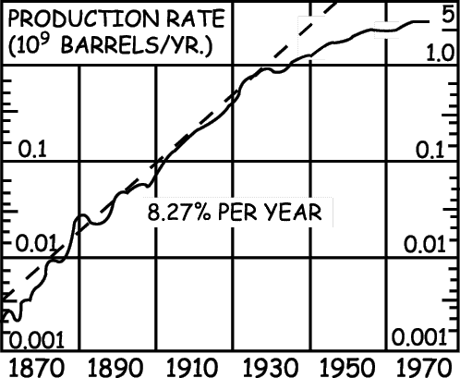

Fig. 1. History of U.S. crude oil production
(semilogarithmic scale).
Redrawn from Hubbert's Fig. 12, Ref. 7.

We are currently importing one-half of the petroleum we use. If these imports were completely cut off and if there was no growth in the rate of domestic consumption above the 1970 rate, our domestic petroleum reserves would last only 14 yr! The vast shale oil deposits of Colorado and Wyoming represent an enormous resource. Hubbert reports that the oil recoverable under 1965 techniques is 80 x 10⁹ barrels, and he quotes other higher estimates. In the preparation of Table V, the figure 103.4 x 10⁹ barrels was used as the estimate of U.S. shale oil so that the reserves used in the calculation of column 4 would be twice those that were used in the calculation of column 3. This table makes it clear that when consumption is rising exponentially, a doubling of the remaining resource results in only a small increase in the life expectancy of the resource.

A reporter from CBS News, speaking about oil shale on a three-hour television special feature on energy (August 31, 1977) said, "Most experts estimate that oil shale deposits like these near Rifle, Colorado, could provide more than a 100-yr supply." This statement should be compared with the figures given in column 4 of Table V. This comparison will serve to introduce the reader to the disturbing divergence between reassuring statements by authoritative sources and the results of simple calculations.

Anyone who wishes to talk about energy self-sufficiency for the United States (Project Independence) must understand Table V and the simple exponential calculations upon which it is based.

Table V.
Exponential expiration time (EET) in years of various estimates of U.S. oil reserves for different rates of growth of annual production. Units are 10⁹ barrels. This table is prepared by using Eq. (6) with r₀ = 3.29 x 10⁹ barrels/yr. Note that this is domestic production which is only about one half of domestic consumption!
Col.1 (%) | Col.2 (yr) | Col.3 (yr) | Col.4 (yr)
Percent annual growth rate | Lifetime (EET) of the resource which is calculated using R = 190 - 96.6 = 93.4 as the estimated oil remaining in the lower 48 states. | Lifetime (EET) calculated using R = 93.4 + 10 to include the Alaskan oil. | Lifetime (EET) calculated using R = 93.4 + 10 + 103.4 = 206.8 to include Alaskan oil and a hypothetical estimate of U.S. oil shale.
Zero | 28.4 | 31.4 | 62.8
1% | 25.0 | 27.3 | 48.8
2% | 22.5 | 24.4 | 40.7
3% | 20.5 | 22.1 | 35.3
4% | 19.0 | 20.4 | 31.4
5% | 17.7 | 18.9 | 28.4
6% | 16.6 | 17.7 | 26.0
7% | 15.6 | 16.6 | 24.1
8% | 14.8 | 15.7 | 22.4
9% | 14.1 | 14.9 | 21.1
10% | 13.4 | 14.2 | 19.9

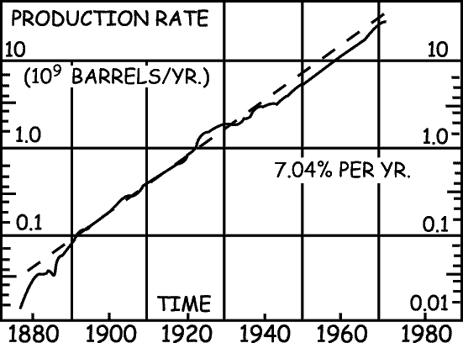

Fig. 2. History of world crude oil production
(semilogarithmic scale).
Redrawn from Hubbert's Fig. 6, Ref. 7.

Table VI gives statistics on world production of crude oil. Figure 2 shows the historical trend in world crude oil production. Note that from 1890 to 1970 the production grew at a rate of 7.04% / yr, with a doubling time of 9.8 yr. It is easy to calculate that the world reserves of crude oil would last 101 yr if the growth in annual production was halted and production in the future was held constant at the 1970 level. Table VII shows the life expectancy (EET) of world crude oil reserves for various rates of growth of production and shows the amount by which the life expectancy is extended if one adds world deposits of oil shale. Column 4 is based on the assumption that the available shale oil is four times as large as the value reported by Hubbert. Note again that the effect of this very large hypothetical increase in the resource is very small.

Table VI.
World crude oil data.
Ultimate total production (Ref.7) | 1952
Produced to 1972 | 261
Percent of total production produced to 1972 (Ref. 7) | 13.4%
Annual Production rate 1970 | 16.7
Units are 10⁹ barrels. Note that a little more than 1/8 of the world's oil has been consumed. The "world petroleum time" is between 2 and 3 min before noon, i.e. we are between 2 and 3 doubling times from the expiration of the resource.

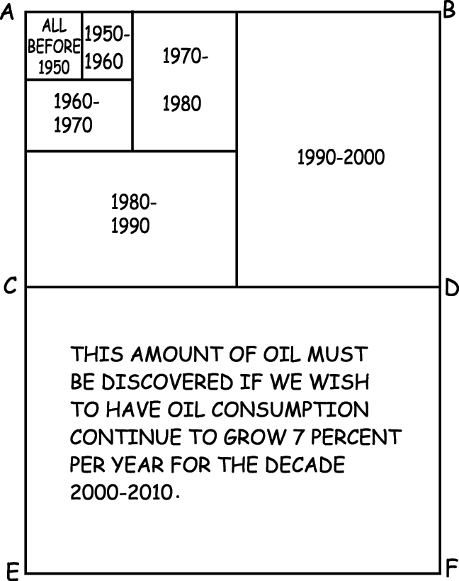
Fig. 3. This graphical model from Mario Iona can be used to represent this growth.¹¹

When consumption grows 7% / yr the consumption in any decade is approximately equal to the sum of all previous consumption as can be seen by the areas representing consumption in successive decades.

The rectangle ABDC represents all the known oil, including all that has been used in the past, and the rectangle CDFE represents the new discoveries that must be made if we wish the 7 % / year growth to continue one decade, from the year 2000 to 2010!

From these calculations we can draw a general conclusion of great importance. When we are dealing with exponential growth we do not need to have an accurate estimate of the size of a resource in order to make a reliable estimate of how long the resource will last.

Table VII.
Life expectancy in years of various estimates of world oil reserves for different rates of growth of annual production. Units are 10⁹ barrels. This table is prepared by using Eq. (6) with r0 = 16.7 x 10⁹ barrels / yr.
Col. 1 (%) | Col. 2 (yr) | Col. 3 (yr) | Col. 4 (yr)
Percent annual growth rate of production | Lifetime (EET) of the resource calculated using r = 1691 as the estimate of the amount of the remaining oil. | Lifetime (EET) calculated using R = 1691 + 190 = 1881 representing crude oil plus oil shale. | Lifetime (EET) calculated using R = 1691 + 4(190) = 2451 which assumes that the amount of shale oil is 4 times the amount which is known now.
Zero | 101.0 | 113.0 | 147.0
1% | 69.9 | 75.4 | 90.3
2% | 55.3 | 59.0 | 68.5
3% | 46.5 | 49.2 | 56.2
4% | 40.5 | 42.6 | 48.2
5% | 36.0 | 37.8 | 42.4
6% | 32.6 | 34.1 | 38.0
7% | 29.8 | 31.2 | 34.6
8% | 27.6 | 28.8 | 31.8
9% | 25.7 | 26.8 | 29.5
10% | 24.1 | 25.1 | 27.5

A friend recently tried to reassure me by asserting that there remained undiscovered under our country at least as much oil as all we have ever used. Since it has been about 120 yr since the first discovery of oil in this country, he was sure that the undiscovered oil would be sufficient for another 120 yr. I had no success in convincing him that if such oil was found it would be sufficient only for one doubling time or about a decade.

As the reader ponders the seriousness of the situation and asks, "What will life be like without petroleum?" the thought arises of heating homes electrically or with solar power and of traveling in electric cars. A far more fundamental problem becomes apparent when one recognizes that modern agriculture is based on petroleum-powered machinery and on petroleum-based fertilizers. This is reflected in a definition of modern agriculture: "Modern agriculture is the use of land to convert petroleum into food."

Item: We have now reached the point in U.S. agriculture where we use 80 gallons of gasoline or its equivalent to raise an acre of corn, but only nine hours of human labor per crop acre for the average of all types of produce.¹²

Think for a moment of the effect of petroleum on American life. Petroleum has made it possible for American farms to be operated by only a tiny fraction of our population; only 1 American in 26 lived on a farm in 1976. The people thus displaced from our farms by petroleum-based mechanization have migrated to the cities where our ways of life are critically dependent on petroleum. The farms without the large number of people to do the work are also critically dependent on petroleum-based mechanization. The approaching exhaustion of the domestic reserves of petroleum and the rapid depletion of world reserves will have a profound effect on Americans in the cities and on the farms. It is clear that agriculture as we know it will experience major changes within the life expectancy of most of us, and with these changes could come a major further deterioration of world-wide levels of nutrition. The doubling time (36 - 42 yr) of world population (depending on whether the annual growth rate is 1.9 % or 1.64 %) means that we have this period of time in which we must double world food production if we wish to do no better than hold constant the fraction of the world population that is starving. This would mean that the number starving at the end of the doubling time would be twice the number that are starving today. This was put into bold relief by David Pimentel of Cornell University in an invited paper at the 1977 annual meeting of AAPT-APS (Chicago, 1977):

As a result of overpopulation and resource limitations, the world is fast losing its capacity to feed itself... More alarming is the fact that while the world population doubled its numbers in about 30 years the world doubled its energy consumption within the past decade. Moreover, the use of energy in food production has been increasing faster than its use in many other sectors of the economy.

It is possible to calculate an absolute upper limit to the amount of crude oil the earth could contain. We simply assert that the volume of petroleum in the earth cannot be larger than the volume of the earth. The volume of the earth is 6.81 x 10²¹ barrels, which would last for 4.1 x 10¹¹ yr if the 1970 rate of consumption of oil held constant with no growth. The use of Eq. (6) shows that if the rate of consumption of petroleum continued on the growth curve of 7.04 % / yr of Fig. 2, this earth full of oil will last only 342 yr!

It has frequently been suggested that coal will answer the U.S. and world energy needs for a long period in the future. What are the facts?

Table VIII shows data on U.S. coal production that are taken from several sources. Figure 4 shows the history of coal production in the U.S. Note that from 1860 to 1910, U.S. coal production grew exponentially at 6.69 % / yr (T₂ = 10.4 yr). The production then leveled off at 0.5 x 10⁹ tons / yr which held approximately constant until 1972 whereupon the rate started to rise steadily. Coal consumption remained level for 60 yr because our growing energy demands were met by petroleum and natural gas. In early 1976 the annual coal production goals of the U.S. government were 1.3 billion tons for 1980 and 2.1 billion tons for 1985. The 1976 production is now reported to have been 0.665 billion tons and the current goal is to raise annual production to a billion tons by 1985.¹³ From these data we can see that the Ford administration's goals called for coal production to increase on the order of 10 % / yr while the Carter administration is speaking of growth of production of approximately 5 % / yr.

Table VIII.
United States coal resource.
Ultimate total production (Ref. 7)
High estimate | 1486
Low estimate | 390
Produced through 1972 (My estimate from Hubbert's Fig. 22) | 50
Percent of ultimate production produced through 1972
Percent of high estimate | 3%
Percent of low estimate | 13%
Coal resource remaining
High estimate | 1436
Low estimate | 340
Annual production rate, 1972 | 0.5
Rate of export of coal, 1974 | 0.06
Annual production rate, 1974 | 0.6
Annual production rate, 1976 | 0.665
Units are 10⁹ metric tons.

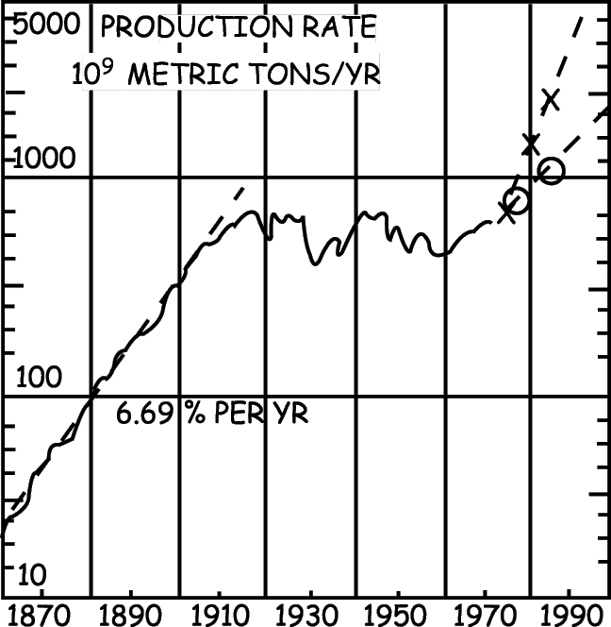
Fig. 4. History of U.S. coal production (semilogarithmic scale). Redrawn from Hubbert's Fig. 10, Ref. 7.

In the upper right, the crosses in the steep dashed curve show the coal production goals of the Ford Administration, and the circles in the lower dashed curve show the production goals of the Carter Administration.

From the close of the American Civil War to about the year 1910, coal production grew at a steady rate of 6.69% / yr. If this growth rate had continued undiminished after 1910, the small estimate of the size of U.S. coal reserves would have been consumed by about 1967 and the larger estimate of the size of the reserves would have been consumed by about the year 1990!

Table IX shows the expiration times (EET) of the high and the low estimates of U.S. coal reserves for various rates of increase of the rate of production as calculated from the equation for the EET [Eq. (6)]. If we use the conservative smaller estimate of U.S. coal reserves we see that the growth of the rate of consumption will have to be held below 3 % / yr if we want coal to last until our nation's tricentennial. If we want coal to last 200 yr, the rate of growth of annual consumption will have to be held below 1 % / yr!
One obtains an interesting insight into the problem if one asks how long beyond the year 1910 could coal production have continued on the curve of exponential growth at the historic rate of 6.69 % / yr of Fig. 4. The smaller estimate of U.S. coal would have been consumed around the year 1967 and the large estimate would have expired around the year 1990. Thus it is clear that the use of coal as an energy source in 1978 and in the years to come is possible only because the growth in the annual production of coal was zero from 1910 to about 1972!

VII. WHAT DO THE EXPERTS SAY?

Now that we have seen the facts let us compare them with statements from authoritative sources. Let us look first at a report to the Congress.
It is clear, particularly in the case of coal, that we have ample reserves.... We have an abundance of coal in the ground. Simply stated, the crux of the problem is how to get it out of the ground and use it in environmentally acceptable ways and on an economically competitive basis... At current levels of output and recovery these reserves can be expected to last more than 500 years.¹⁴

Here is one of the most dangerous statements in the literature. It is dangerous because news media and the energy companies pick up the idea that "United States coal will last 500 years" while the media and the energy companies forget or ignore the important caveat with which the sentence began, "At current levels of output . . ." The right-hand column of Table IX shows that at zero rate of growth of consumption even the low estimate of the U.S. coal resource "will last over 500 years." However, it is absolutely clear that the government does not plan to hold coal production constant "at current levels of output."

Table IX.
Lifetime in years of United States coal (EET). The lifetime (EET) in years of U.S. coal reserves (both the high and low estimate of the U.S.G.S.) are shown for several rates of growth of production from the 1972 level of 0.5 (x10⁹) metric tons per year.
 |  | High Estimate (yr) | Low Estimate (yr)
A  N  N  U  A  L  G  R  O  W  T  H  R  A  T  E | Zero | 2872 | 680
A  N  N  U  A  L  G  R  O  W  T  H  R  A  T  E | 1% | 339 | 205
A  N  N  U  A  L  G  R  O  W  T  H  R  A  T  E | 2% | 203 | 134
A  N  N  U  A  L  G  R  O  W  T  H  R  A  T  E | 3% | 149 | 102
A  N  N  U  A  L  G  R  O  W  T  H  R  A  T  E | 4% | 119 | 83
A  N  N  U  A  L  G  R  O  W  T  H  R  A  T  E | 5% | 99 | 71
A  N  N  U  A  L  G  R  O  W  T  H  R  A  T  E | 6% | 86 | 62
A  N  N  U  A  L  G  R  O  W  T  H  R  A  T  E | 7% | 76 | 55
A  N  N  U  A  L  G  R  O  W  T  H  R  A  T  E | 8% | 68 | 50
A  N  N  U  A  L  G  R  O  W  T  H  R  A  T  E | 9% | 62 | 46
A  N  N  U  A  L  G  R  O  W  T  H  R  A  T  E | 10% | 57 | 42
A  N  N  U  A  L  G  R  O  W  T  H  R  A  T  E | 11% | 52 | 39
A  N  N  U  A  L  G  R  O  W  T  H  R  A  T  E | 12% | 49 | 37
A  N  N  U  A  L  G  R  O  W  T  H  R  A  T  E | 13% | 46 | 35

Coal reserves far exceed supplies of oil and gas, and yet coal supplies only 18 % of our total energy. To maintain even this contribution we will need to increase coal production by 70 % by 1985, but the real goal, to increase coal's share of the energy market will require a staggering growth rate.¹⁵

While the government is telling us that we must achieve enormous increases in the rate of coal production, other governmental officials are telling us that we can increase the rate of production of coal and have the resource last for a very long time.
The trillions of tons of coal lying under the United States will have to carry a large part of the nation's increased energy consumption, says (the) Director of the Energy Division of the Oak Ridge National Laboratories. He estimated America's coal reserves are so huge, they could last "a minimum of 300 years and probably a maximum of 1000 years."¹⁶

Compare the above statement of the life expectancy of U.S. coal reserves with the results of very simple calculations given in Table IX.

In the three-hour CBS television special on energy (August 31, 1977) a reporter stressed the great efforts that are being made to increase the rate of production of U.S. coal, and he summarized the situation in these words, "By the lowest estimate, we have enough (coal) for 200 years. By the highest, enough for more than a thousand years."

Again, compare the above statement with the results of simple calculations shown in Table IX.

While we read these news stories we are bombarded by advertisements by the energy companies which say that coal will last a long time at present rates of consumption and which say at the same time that we must dramatically increase our rate of production of coal.
At the rate the United States uses coal today, these reserves could help keep us in energy for the next two hundred years . . . Most coal used in America today is burned by electric power plants (which) consumed about 400 million tons of coal last year. By 1985 this figure could jump to nearly 700 million tons.¹⁷

Other advertisements stress just the 500 years (no caveat): "We are sitting on half the world's known supply of coal -- enough for over 500 years."¹⁸ Some ads stress the idea of self-sufficiency without stating for how long a period we might be self-sufficient. "Coal, the only fuel in which America is totally self-sufficient."¹⁹ Other ads suggest a deep lack of understanding of the fundamentals of the exponential function.

Yet today there are still those who shrill (sic) for less energy and no growth... Now America is obligated to generate more energy - not less - merely to provide for its increasing population... With oil and gas in short supply, where will that energy come from? Predominately from coal. The U.S. Department of the Interior estimates America has 23 % more coal than we dreamed of, 4,000,000,000,000 (trillion!) tons of it. Enough for over 500 years. (The non-sentences are in the original.)²⁰

A simple calculation of the EET based on a current production rate of 0.6 x 10⁹ tons / yr shows that the growth in the rate of production of coal can't exceed 0.8 % / yr if the ad's 4 x 10¹² tons of coal is to last for the ad's 500 yr. However, it should be noted that the 4 x 10¹² tons cited in the ad is 2.8 times the size of the large estimate of U.S. coal reserves and is 12 times the size of the small estimate of U.S. coal reserves as cited by Hubbert.

When we view the range of creative information that is offered to the public we cannot wonder that people are confused. We may wish that we could have rapid growth of the rate of consumption and have the reserves of U.S. coal last for a large number of years, but very simple calculations are all that is needed to prove that these two goals are incompatible. At this critical time in our nation's history we need to shift our faith to calculations (arithmetic) based on factual data and give up our belief in Walt Disney's First Law: "Wishing will make it so."²¹

On the broad aspects of the energy problem we note that the top executive of one of our great corporations is probably one of the world's authorities on the exponential growth of investments and compound interest. However, he observes that "the energy crisis was made in Washington." He ridicules "the modern-day occult prediction" of "computer print-outs" and warns against extrapolating past trends to estimate what may happen in the future. He then points out how American free-enterprise solved the great "Whale Oil Crisis" of the 1850s. With this single example as his data base he boldly extrapolates into the future to assure us that American ingenuity will solve the current energy crisis if the bureaucrats in Washington will only quit interfering.²² It is encouraging to note that the person who made these statements in 1974, suggesting that the energy crisis was contrived rather than real, has now signed his name on an advertisement in Newsweek Magazine (Sept. 12, 1977) saying that, "Energy is not a political issue. It's an issue of survival. Time is running out." However, the same issue of Newsweek Magazine carried two advertisements for coal which said: "We've limited our use of coal while a supply that will last for centuries sits under our noses... Coal _can provide our energy needs for centuries to come."

Carefully read this ad by the Edison Electric Institute for the Electric Companies telling us that: "There is an increasing scarcity of certain fuels. But there is no scarcity of energy. There never has been. There never will be. There never could be. Energy is inexhaustible." (Emphasis is in the original.)²³ We can read that a professor in a school of mining technology offers "proof" of the proposition: "Mankind has the right to use the world's resources as it wishes, to the limits of its abilities . . ."²⁴

We have the opening sentence of a major scientific study of the energy problem: "The United States has an abundance of energy resources; fossil fuels (mostly coal and oil shale) adequate for centuries, fissionable nuclear fuels adequate for millennia and solar energy that will last indefinitely."²⁵ We can read the words of an educated authority who asserts that there is no problem of shortages of resources: "It is not true that we are running out of resources that can be easily and cheaply exploited without regard for future operations." His next sentence denies that growth is a serious component of the energy problem, "It is not true that we must turn our back on economic growth"(emphasis is in the original). Three sentences later he says that there may be a problem: "We must face the fact that the well of nonrenewable natural resources is not bottomless."²⁶ He does suggest that lack of "leadership" is part of the problem.

We have a statement by Ralph Nader, "The supply of oil, gas, and coal in this country is enormous and enough for hundreds of years. It is not a question of supply but a question of price and profits, of monopolies and undue political influence."²⁷

Expert analysis of the problem can yield unusual recommendations. We have the opening paper in an energy conference in which a speaker from a major energy company makes no mention of the contribution of growth to the energy crisis when he asserts that: "The core of the energy problem both U.S. and worldwide [is] our excessive dependence on our two scarcest energy resources - oil and natural gas." For him continued growth is not part of the problem, it is part of the solution! More energy must be made available at a higher rate of growth than normal - in the neighborhood of 6 percent per year compared to a recent historical growth rate of 4 percent per year.²⁸

The patient is suffering from cancer, and after a careful study, the doctor prescribes the remedy; give the patient more cancer. Here is a second case where cancer is prescribed as the cure for cancer. The National Petroleum Council in its report to the energy industry on the energy crisis: observed that "Restrictions on energy demand growth could prove (to be) expensive and undesirable. . . The Council 'flatly rejected' any conservation-type measures proposing instead the production of more energy sources domestically and the easing of environmental controls."²⁹

Study this statement carefully: "Energy industries agree that to achieve some form of energy self-sufficiency the U.S. must mine all the coal that it can."³⁰ The plausibility of this statement disappears and its real meaning becomes apparent when we paraphrase it: "The more rapidly we consume our resources, the more self-sufficient we will be." David Brower has referred to this as the policy of "Strength through Exhaustion." ³¹ This policy has many powerful adherents. For example, on the three-hour CBS television special on energy (Aug. 31, 1977) William Simon, energy adviser to President Ford said: "We should be "trying to get as many holes drilled as possible to get the proven (oil) reserve . . ."

Is it in the national interest to get and use these reserves as rapidly as possible? We certainly get no sense of urgency from the remarks of the Board Chairman of a major multinational energy corporation who concludes the discussion "Let's Talk Frankly About Energy" with his mild assessment of what we must do. "Getting on top of the energy problem won't be easy. It will be an expensive and time-consuming task. It will require courage, creativeness and discipline . . ."³²

If one searches beyond the work of Hubbert for an indication of others who understand the fundamental arithmetic of the problem one finds occasional encouraging evidence.³³ However, when one compares the results of the simple exponential calculations with news stories, with statements from public officials, and with assertions in advertisements of the energy companies it is hard to imagine that this arithmetic is widely understood.

The arithmetic of growth is the forgotten fundamental of the energy crisis.

VIII. A WORD OF CAUTION

We must note that these calculations of the EET of fossil fuels are not predictions of the future. They simply give us first-order estimates of the life expectancies of known quantities of several fuels under the conditions of steady growth which our society and our government hold sacred. These estimates are emphasized as aids to understanding the consequences of any particular growth scenario that the reader may want to consider or to evaluate.

The rate of production of our mineral resources will not rise exponentially until the EET is reached and then plunge abruptly to zero, as modeled in these calculations and as shown in curve A of Fig. 5 even though our national goals are predicated on uninterrupted growth.

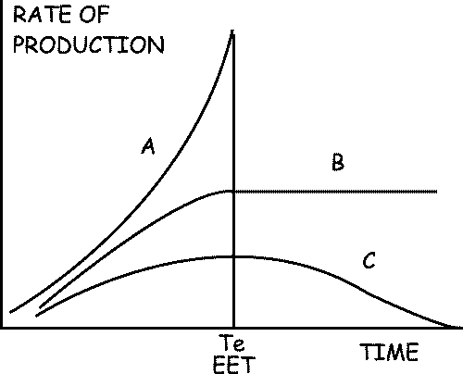
Fig. 5. Three patterns of growth. Curve A represents steady exponential growth in the rate of production of a non-renewable resource until the resource is exhausted at T_{e}, the exponential expiration time (EET). The area under the curve from the present (t = 0) to t = T_{e} is equal to the known size of the resource. Curve C represents Hubbert's model of the way in which the rate of production of a nonrenewable resource rises and falls. This model is based on studies of the rate of use of resources which have been nearly completely consumed. The area under the curve from the present to t = infinity is equal to the size of the resource. Curve B represents the rate of production of a renewable resource such as agricultural or forest products, where a constant steady-state production can be maintained for long periods of time provided this production is not dependent on the use of a nonrenewable resource (such as petroleum) whose production is following a curve such as C.

The rate of production of our nonrenewable mineral resources will not follow the classical S-shaped transition from an early period of exponential growth to a horizontal curve representing a constant rate of production, curve B. Such a curve can be achieved in the production of renewable resources such as food, forest products, or the production of solar energy, provided the rate of production of the renewable resource is not dependent on fossil fuels. Reference has already been made to the dependence of modern agriculture on petroleum, and as long as this dependence continues, the curve of agricultural production would be expected to follow curve C, (the curve for nonrenewable petroleum) rather than curve B. Although the rate of production of mineral resources has been growing exponentially, one knows that at some time in the future the resource will be exhausted and the rate of production will return to zero. The past history, this one future datum and a careful study of the rate versus time of production of resources that have expired has led Dr. M. King Hubbert to the conclusion that the rate of production of a nonrenewable resource will rise and fall in the symmetrical manner of a Gaussian error curve as shown in curve C of Fig. 5. When he fits the data for U.S. oil production in the lower 48 states to a curve such as C, Hubbert finds that we are now just to the right of the peak. We have used one-half of the recoverable petroleum that was ever in the ground in the U.S. and in the future the rate of production can only go downhill. However, our national demand for petroleum has continued to grow exponentially and the difference between our demands and our production has been made up by imports. Bold initiatives by the Congress could temporarily reverse the trend and could put a small bump on the downhill side of the curve. Alaskan oil can put a little bump on the downhill side of the curve. The downhill trend on the right side of the curve was noted clearly by Deputy Energy Secretary John O'Leary under the headline, "U.S. Energy 'Disaster' Inevitable by 1985,"³⁴
Although U.S. oil and gas production hit their peak several years ago and are declining by about 8 percent per year, O'Leary said, the nation has avoided serious problems by using more foreign oil...We are walking into a disaster in the next three or four years with our eyes wide open.

The most dramatic conclusion that Hubbert draws from his curve for the complete cycle of U.S. oil production is that the consumption of the central 80 % of the resource will take place in only 67 yr!
It is very sobering to face the downhill side of the curve and to note that in the past the rise in our annual per capita consumption of energy has gone hand-in-hand with the increase of our standard of living. It is more sobering to note the close coupling between our production of food and our use of petroleum. It is even more sobering to note that on March 7, 1956 (over 22 years ago) Dr. Hubbert, addressing the conference in San Antonio, Texas, of a large group of petroleum engineers and geologists said:
According to the best currently available information, the production of petroleum and natural gas on a world scale will probably pass its climax within the order of half a century, while for both the United States and for Texas, the peaks of production can be expected to occur within the next 10 or 15 years. (i.e., between 1966 and 1971)

Pazik tells³³ of the shock this statement and the related analysis caused in oil industry circles and he tells about the efforts that were made by the "experts" to ignore this and the other results of the analysis made by Hubbert.

IX. WHAT DO WE DO NOW?

The problems are such that we have rather few options. All of the following points are vital:

- We must educate all of our people to an understanding of the arithmetic and consequences of growth, especially in terms of the earth's finite resources. David Brower has observed that, "The promotion of growth is simply a sophisticated way to steal from our children."
- We must educate people to the critical urgency of abandoning our religious belief in the disastrous dogma that "growth is good," that "bigger is better," that "we must grow or we will stagnate," etc., etc. We must realize that growth is but an adolescent phase of life which stops when physical maturity is reached. If growth continues in the period of maturity it is called obesity or cancer. Prescribing growth as the cure for the energy crisis^{28, 29} has all the logic of prescribing increasing quantities of food as a remedy for obesity. The recent occasion of our nation's 200th anniversary would be an appropriate time to make the transition from national adolescence to national maturity.
- We must conserve in the use and consumption of everything. We must outlaw planned obsolescence. We must recognize that, as important as it is to conserve, the arithmetic shows clearly that large savings from conservation will be wiped out in short times by even modest rates of growth. For example, in one or two dozen years a massive federal program might result in one-half of the heat for the buildings where we live and work being supplied by solar energy instead of by fossil fuels. This would save 10 % of our national use of fossil fuels, but this enormous saving could be completely wiped out by two years of 5 % growth. Conservation alone cannot do the job! The most effective way to conserve is to stop the growth in consumption.

As we consider the absolute urgency of conservation we must recognize that some powerful people are hostile to the concept of conservation. One of our great multinational oil companies has advertised that conservation is: "Good for you - but not if there's too much." And in the same ad they noted that: "Conservation does no harm."³⁵

In his message to the American people President Carter proposed a tax on large "gas guzzling" cars. General Motors Chairman Thomas Murphy had the following reaction to this proposal to conserve energy: Murphy calls the excise tax on big cars, coupled with rebates on small cars "one of the most simplistic irresponsible and short-sighted ideas ever conceived by the hip-shooting marketeers of the Potomac."³⁶

Big labor is hostile to this same conservation measure. Leonard Woodcock, President of the United Auto Workers said of the tax: "I respectfully suggest that the proposal is wrong. It is not properly thought through and should be withdrawn."³⁷

Congress is not enthusiastic about conservation: "Look for Senate leaders on both sides of the aisle - including Chairman Russell Long of the Finance Committee and Minority Leader Howard Baker - to gang up on Carter's energy package. The two influential lawmakers want more stress on the production of oil, not so much on conservation."³⁸

Closer to home we can note that our governors don't show much enthusiasm for conservation: "The nation's governors told President Carter that the federal government is placing too much emphasis on conservation and not enough on developing new resources."³⁹

With all this influential opposition one can see how difficult it will be to launch major national programs of energy conservation.

- We must recycle almost everything. Except for the continuous input of sunlight the human race must finish the trip with the supplies that were aboard when the "spaceship earth" was launched.
- We must invest great sums in research (a) to develop the use of solar, geothermal, wind, tidal, biomass, and alternative energy sources; (b) to reduce the problems of nuclear fission power plants; (c) to explore the possibility that we may be able to harness nuclear fusion. These investments must not be made with the idea that if these research programs are successful the new energy sources could sustain growth for a few more doubling times. The investments must be made with the goal that the new energy sources could take over the energy load in a mature and stable society in which fossil fuels are used on a declining exponential curve as chemical raw materials and are not used as fuel for combustion. One great area of responsibility of our community of scientists and engineers is vigorous pursuit of research and development in all these areas. These areas offer great opportunity to creative young people.
Perhaps the most critical things that we must do is to decentralize, and consequently humanize, the scale and scope of our national industrial and utility enterprises.⁴⁰
- We must recognize that it is exceedingly unscientific to promote ever-increasing rates of consumption of our fuel resources based on complete confidence that science, technology, and the economics of the marketplace will combine to produce vast new energy resources as they are needed. Note the certainty that characterizes this confidence.
Coal could help fight a rear-guard action to provide time for scientific breakthroughs which will move the world from the fossil fuel era of wood, gas, oil, and coal to the perpetual energy era of infinitely renewable energy resources.⁴¹ The supply (of coal) is adequate to carry the U.S. well past the transition from the end of the oil and gas era to new, possibly not discovered sources of energy in the 2000s.⁴²
There seems to be an almost complete absence of the caution that would counsel us to stop the growth of our national energy appetite until these "unlimited energy resources" are proven to be capable of carrying the national energy load. We must recognize that it is not acceptable to base our national future on the motto "When in doubt, gamble."
Fusion is most commonly mentioned as being an unlimited energy source. The optimism that leads some people to believe that fusion power will be ready whenever it is needed should be balanced against this opening statement in a report on fusion from MIT. "Designing a fusion reactor in 1977 is a little like planning to reach heaven: theories abound on how to do it, and many people are trying, but no one alive has ever succeeded."⁴³
If the generation of electric power from fusion was achieved today, we could ask how long would it then be before fusion could play a significant role in our national energy picture. The time-constant for the replacement of one major energy source by another can be estimated from the fact that the first nuclear fission reactor was operated in December 1942. Even though the recent growth of nuclear energy in the U.S. has been spectacular, it was not until around 1972 that annual energy consumption equaled our annual energy consumption from firewood! By 1973 nuclear energy had climbed to the point where it supplied 1.3 % of our U.S. total annual energy consumption and 4.6 % of our electrical power.⁴⁴ Thus in 31 years nuclear energy has grown to provide only a small fraction of our energy needs. Had there been no growth of our national electrical needs since 1942, today's nuclear plants would be supplying 41 % of our national electrical power.
- We can no longer sit back and deplore the lack of "leadership" and the lack of response of our political system. In the immortal words of Pogo "We have met the enemy, and they's us." We are the leaders, we are vital parts of the political system and we have an enormous responsibility.

The arithmetic makes clear what will happen if we hope that we can continue to increase our rate of consumption of fossil fuels. Some experts suggest that the system will take care of itself and that growth will stop naturally, even though they know that cancer, if left to run its natural course, always stops when the host is consumed. My seven suggestions are offered in the spirit of preventive medicine.

X. CONCLUSION

The preceding calculations are offered as guideposts which must be understood by those who would deal constructively with the energy crisis. The role and limitations of science in analyzing and in solving our problems was beautifully expressed by Gustav Lebon (1841-1931).

"Science has promised us truth; an understanding of such relationships as our minds can grasp. It has never promised us either peace or happiness."

Perhaps the most succinct conclusion that is indicated by the analysis above is taken from the immortal words of Pogo, "The future ain't what it used to be!" The American system of free enterprise has flourished for 200 years with spectacular achievements. Until recently it flourished in a world whose energy resources were essentially infinite. Whenever one fossil fuel came into short supply, another could always be found to take its place. We are now close enough that we can see the end of the world's total supply of fossil fuels. The challenge that we must meet is set forth clearly in the question, "Can free enterprise survive in a finite world?" President Carter observed (April 18, 1977) that: "If we fail to act soon we will face an economic, social, and political crisis that will threaten our free institutions." (See Fig. 6)

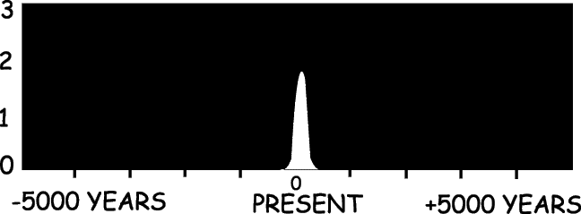
Fig. 6. The delta function in the darkness. Redrawn from Hubbert's Fig. 69, Ref. 7. The epoch of the world's use of its fossil fuels is shown on a time scale of human history from 5000 yr ago to 5000 yr in the future. The vertical axis is the rate of consumption of fossil fuels measured in units of 10¹⁴ kW h / yr. The vertical scale is a linear scale.

XI. A POSTSCRIPT FOR SCIENCE TEACHERS

For decades physics teachers throughout the world have discussed the RC circuit and the decay of radioactive atoms and have thus introduced the simple differential equation that gives rise to exponential decay of the charge on the capacitor or of the number of remaining radioactive nuclei. These provide a wonderful opportunity for us to digress and to point out that exponential arithmetic has great value outside of these two special examples in physics and to show our students that exponential arithmetic is probably the most important mathematics they will ever see. It is especially important for students to see how the change in the sign of the exponent can make an enormous difference in the behavior of the function. But we will need to do more. We must integrate the study of energy and of the exponential arithmetic into our courses as has been done, for example, in one new text.⁴⁴ In addition, we have an even larger task. As science teachers we have the great responsibility of participating constructively in the debates on growth and energy. We must be prepared to recognize opinions such as the following, which was expressed in a letter to me that was written by an ardent advocate of "controlled growth" in our local community: "I take no exception to your arguments regarding exponential growth. I don't think the exponential argument is valid on the local level."

We must bring to these debates the realism of arithmetic and the new concept of precision in the use of language. We must convey to our students the urgency of analyzing all that they read for realism and precision. We must convey to our students the importance of making this analysis even though they are reading the works of an eminent national figure who is writing in one of the world's most widely circulated magazines. (The emphasis in the following quotations is in the original.
The simple truth is that America has an abundance of energy resources... An estimated 920 trillion cubic feet of natural gas still lies beneath the United States. Even at present consumption rates, this should last at least 45 years... About 160 billion barrels of oil still lie below native ground or offshore. That's enough to last us into the next century at present rates of consumption.⁴⁵

When students analyze these statements they can see that the first statement is false if "abundance" means "sufficient to continue currently accepted patterns of growth of rates consumption for as long as one or two human lifetimes." An evaluation of the second and third statements show that they are falsely reassuring because they suggest the length of time our resources will last under the special condition of no growth of the rates of use of these resources. The condition of no growth in these rates is absolutely contrary to the precepts of our national worship of growth. It is completely misleading to introduce the results of "no growth:" unless one is advocating "no growth."

If it is true that our natural gas reserves will last 45 yr at present rates of consumption ( R / r₀ = 45 yr), then Eq. (6) shows that this amount of gas would last only 23.6 yr at an annual growth rate of 5 % / yr, and only 17 yr at an annual growth rate of 10 % / yr. When the third statement is analyzed one sees that the given figure of 160 x 10⁹ barrels of reserves is roughly 60 % larger than Hubbert's estimate. This amount would last 49 yr if oil was produced at the 1970 rate of 3.3 x 10⁹ barrels / yr, held constant with no growth. However, our domestic consumption is now roughly twice the rate of domestic production, so this amount of oil would satisfy domestic needs for only about 25 yr if there was no growth in these domestic needs. If R / r₀ = 25 yr, then Eq. (6) shows that this amount of oil would last only 16.2 yr if production grew 5 % / yr and only 12.5 yr if it grew 10 % / yr.

We can conclude that the author is probably advocating growth in the rate at which we use fossil fuels from the following imprecise statement, "The fact is that we must produce more energy." Therefore the author's statements about the life expectancy of resources at current rates of use are irrelevant. When they are offered as reassurance of the lack of severity of our energy problem they are dangerously and irresponsibly misleading.

Students should be able to evaluate the same author's statement about coal, "At least 220 billion tons of immediately recoverable coal - awaits mining in the United States." This "could supply our energy needs for several centuries." Students can see that the size of the coal reserves given by the author is significantly smaller than either of the two estimates given by Hubbert. They can see that it is imprecise and meaningless to suggest how long a resource will last if one says nothing about the rate of growth of production. In addition to encouraging our students to carry out their responsibility to analyze what they read, we must encourage them to recognize the callous (and probably careless) inhumanity of a prominent person who is perhaps in his fifties,⁴⁵ offering reassurance to younger readers to the effect, "don't worry, we have enough petroleum to last into the next century," The writer is saying that "There is no need for you to worry, for there is enough petroleum for the rest of my life." Can we accept the urgings of those who advocate unending expansion and growth in the rates of consumption of our fossil fuel resources and who say "Why worry, we have enough to last into the next century."

We must give our students an appreciation of the critical urgency of evaluating the vague, imprecise, and meaningless statements that characterize so much of the public debate on the energy problem. The great benefits of the free press place on each individual the awesome responsibility of evaluating the things that he or she reads. Students of science and engineering have special responsibilities in the energy debate because the problems are quantitative and therefore many of the questions can be evaluated by simple analysis.

Students must be alert not only to the writings in the popular press but to the writings in college textbooks. In the bookstore of a school of engineering I purchased a book that was listed for one of the courses, possibly in political science. Here are a few interesting statements from the book:⁴⁶

Our population is not growing too rapidly, but much too slowly... To approach the problem ("the population scare") from the standpoint of numbers per se is to get the whole thing hopelessly backward... Our coal supply alone, for example, is sufficient to power our economy for anywhere for 300 to 900 years - depending on the uses to which it is put - while gas and oil and coal together are obviously good for many centuries... So whatever the long-term outlook for these energy sources, it is obvious (that) natural shortage cannot account for the present energy crunch.

Dr. Hubbert, speaking recently, noted that we do not have an energy crisis, we have an energy shortage. He then observed that the energy shortage has produced a cultural crisis.

We must emphasize to our students that they have a very special role in our society, a role that follows directly from their analytical abilities. It is their responsibility (and ours) to become the great humanists.

Note added in proof:

Two incredible misrepresentations of the life expectancy of U.S. coal reserves have been called to my attention recently. Time (April 17, 1978, p.74) said:
Beneath the pit heads of Appalachia and the Ohio Valley, and under the sprawling strip mines of the West, lie coal seams rich enough to meet the country's power needs for centuries, no matter how much energy consumption may grow." (emphasis added)

In reply to my letter correcting this, Time justified their statement by saying that they were using the Citibank estimate of U.S. coal reserves which is larger than the estimate used by Hubbert.

A beautiful booklet, "Energy and Economic Independence" (Energy Fuels Corporation of Denver, Denver, 1976) said: "As reported by Forbes magazine, the United States holds 437 billion tons of known (coal) reserves. That is equivalent to 1.8 trillion barrels of oil in British Thermal units, or enough energy to keep 100 million large electric generating plants going for the next 800 years or so." (emphasis added) This is an accurate quotation from Forbes, the respected business magazine (December 15, 1975, p.28). Long division is all that is needed to show that 437 x 10⁹ tons of coal would supply our 1976 production of 0.665 x 10⁹ tons per year for only 657 years, and we probably have fewer than 500 large electric generating plants in the U.S. today. This booklet concluded, "Your understanding of the facts about 'energy and economic independence' issue is of great importance."

A very thoughtful comment on fusion was made to me recently by a person who observed that it might prove to be the worst thing that ever happened to us if we succeed in using nuclear fusion to generate electrical energy because this success would lead us to conclude that we could continue the unrestrained growth in our annual energy consumption to the point (in a relatively few doubling times) where our energy production from the unlimited fusion resource was an appreciable fraction of the solar power input to the earth. This could have catastrophic consequences.

Richard Stout, columnist for the New Republic, noted (Time, March 27, 1978, p.83) that in America, "We consume one third of all the energy, one third of the food and enjoy one half of the world's income. Can a disparity like this last? I think that much of the news in the next 50 years is going to turn on whether we yield to the inevitable graciously or vindictively."

ACKNOWLEDGEMENTS

A great deal of correspondence and hundreds of conversations with dozens of people over six years have yielded many ideas, suggestions, and facts which I have incorporated here. I offer my sincere thanks to all who have helped.

APPENDIX

When a quantity such as the rate r( t ) of consumption of a resource grows a fixed percent per year, the growth is exponential:

r ( t ) = r₀ e ^{k t} = r₀ 2 ^{t / T2} (1)

where r₀ is the current rate of consumption at t = 0, e is the base of natural logarithms, k is the fractional growth per year, and t is the time in years. The growing quantity will increase to twice its initial size in the doubling time T₂where:

T₂ (yr) = (ln 2) / k = approx. 70 / P (2)

and where P, the percent growth per year, is 100k. The total consumption of a resource between the present (t = 0) and a future time T is:

(3)

The consumption in a steady period of growth is:

(4)

If the known size of the resource is R tons, then we can determine the exponential expiration time (EET) by finding the time T_{e} at which the total consumption C is equal to R:

R = ( r₀ / k ) ( e ^{kTe} - 1 ) (5)

We may solve this for the exponential expiration time T_{e} where:

EET = T_{e} = ( 1 / k ) ln ( k R / r₀ + 1 ) (6)

This equation is valid for all positive values of k and for those negative values of k for which the argument of the logarithm is positive.

REFERENCES

- This paper is based on a series of articles, "The Exponential Function" which is appearing in The Physics Teacher:
(a) Vol. 14, p. 393 (Oct. 1976); (b) Vol. 14, p. 485 (Nov. 1976); (c) Vol. 15, p. 37 (Jan. 1977); (d) Vol. 15, p. 98 (Mar. 1977); (e) Vol. 15, p. 225 (Apr. 1977); (f) Vol. 16, p. 23 (Jan. 1978); (g) Vol. 16, p. 92 (Feb. 1978); (h) Vol. 16, p. 158 (Mar. 1978). An early version of this paper was presented at the Third Annual UMR-MEC Conference on Energy, held at the University of Missouri at Rolla, Oct. 12-14, 1976, and appears in the volume of the Proceedings of the Conference. The early version, or minor revisions of it have been published in Not Man Apart published by Friends of the Earth: July / Aug. 1977, Vol. 7, No. 14 pp. 12-13; The Vermillion Flycatcher (Tucson, Arizona Audubon Society, December 1977); The Colorado Business Review (Grad. Sch. of Business Admin. of the University of Colorado, Jan / Feb 1978).
- Newsweek, Dec. 6, 1976.
- A. A. Bartlett; Civil Engineering, Dec. 1969, p. 71.
- Time, April 25, 1977, p. 27.
- W. Von Engelhardt, J. Goguel, M. King Hubbert, J. E. Prentice, R.A. Price, and R. Trumpy; Environmental Geology, Vol. 1, 193-206 (1976).
- A. A. Bartlett, Proceedings of the Third Annual UMR-MEC Conference on Energy, University of Missouri at Rolla, Missouri, October 12-14, 1976, p. 10.
- U.S. Energy Resources, a Review as of 1972, a background paper prepared at the request of the Hon. Henry M. Jackson, Chairman of the Committee on Interior and Insular Affairs of the United States Senate, pursuant to Senate Resolution 45: M. King Hubbert, A National Fuels and Energy Policy Study, Serial 93-40 (92-75) Part 1 (U.S. GPO, Washington, D.C., 1973), $2.35, 267 pages. This document is an invaluable source of data on consumption rates and trends in consumption, for both the U.S.A. and the world. In it Hubbert also sets forth the simple calculus of his methods of analysis. He does not confine his attention solely to exponential growth. He predicts that the rate of rise and subsequent fall of consumption of a resource will follow a symmetrical curve that looks like the normal error curve. Several figures in this paper are redrawn from Hubbert's paper.
- L. Ruedisili and M. Firebaugh, Perspectives on Energy, (Oxford University Press, New York, 1975).
- M. King Hubbert, Resources and Man, National Academy of Sciences and National Research Council, (Freeman, San Francisco, 1969), Chapter 8.
- M. King Hubbert, "Energy Resources of the Earth," Scientific American, Sept. 1971, p. 60. Reprinted as a book (Freeman, San Francisco, 1971).
- M. Iona, Physics Teacher, Vol. 15, p. 324 (1977).
- Emile Benoit, "The Coming Age of Shortages," Bulletin of Atomic Scientists, January 1976, p. 7. Benoit attributes his information to David Pimintel et al., "Food Production and the Energy Crisis," Science, Vol. 182, p. 448 (Nov. 2, 1973). This article is the first of three by Benoit (Bulletin of Atomic Scientists, Jan., Feb., Mar., 1976,). These are one of the best presentations I have read of coming problems of food, fuels, and resources.
- Newsweek, Jan. 31, 1977.
- "Factors Affecting the Use of Coal in Present and Future Energy Markets" a background paper prepared by The Congressional Research Service at the request of Sen. Henry M. Jackson, Chairman of the Committee on Interior and Insular Affairs of the United States Senate pursuant to Senate Resolution 45, a National Fuels and Energy Policy Study Serial No. 93-9 (92-44) (U.S. GPO, Washington, D.C., 1973) pp. 41, 42, 15.
- "The Energy Crisis" a booklet by the U.S. Energy Research and Development Agency (ERDA) Oak Ridge, Tennessee, no date, p. 3. (1975 or 1976).
- Associated Press story "Energy Head Stresses Coal Reserves," in the Boulder Daily Camera, July 5, 1975.
- "America's Coal: A Gold Mine of Energy," Exxon Corporation two-page full-color ad in Newsweek, 1975.
- "They're trying to tell us something. We're foolish not to listen," American Electric Power Company, Inc. Two-page ad in Newsweek, 1975.
- "The call to greater energy independence" American Electric Power Company, Inc., ad in Newsweek, Nov. 3, 1975.
- "An open letter on energy to those who are still employed." American Electric Power Company, Inc., ad in Newsweek, Jan. 12, 1976.
- W. H. Miernyk, Journal of Energy and Development, Vol. 1, No. 2, p. 223 (1976).
- "The Whale Oil, Chicken, and Energy Syndrome," an address before the Economic Club of Detroit by Walter B. Wriston, Chairman, First National City Corporation, Feb. 25, 1974.
- "The Transitional Storm, Part I, An Explanation," by the Edison Electric Institute for the Electric Companies, in Broadcasting, July 26, 1976.
- Charles O. Frush, "Moral Basis for Mineral Resource Use and Development Policy" The Mines Magazine, Colorado School of Mines, March 1973, p. 20.
- J. C. Fisher, "Physics and the Energy Problem," Physics Today, American Institute of Physics, New York, 1974.
- "Opening Remarks, UMR-MEC Conference on Energy," R. L. Bisplinghoff, Proceedings of the Conference, Oct. 7-9, 1975, University of Missouri at Rolla.
- Washington Star, Feb. 12, 1977.
- L. G. Hauser, "Creating the Electric Energy Economy," Proceedings of the Second Annual UMR-MEC Conference on Energy, October 7-9, 1975, p. 3., University of Missouri at Rolla.
- Gil Bailey, "Conservation - Development Proposed As Solution," Washington Bureau of the Boulder Daily Camera, March 13, 1973.
- Time, May 19, 1975, p. 55.
- D. Brower, Not Man Alone, Vol. 6, No. 20, Nov. 1976; Friends of the Earth, 529 Commercial, San Francisco.
- C. C. Garvin, Jr., Chairman of the Exxon Corporation; Full page ad in the Rocky Mountain News, July 23, 1976.
- G. Pazik, in a special editorial feature, "Our Petroleum Predicament," in Fishing Facts ("The magazine for today's freshwater fisherman"), Northwoods Publishing Co., P.O. Box 609, Menomonee Falls, WI 53051. Nov. 1976. Reprints are available at $0.30 each from the publisher. This is an excellent summary of the present situation and of the way we got into our petroleum predicament.
- The Arizona Republic, Feb. 8, 1978.
- "Conservation is like Cholesterol" an ad copyrighted 1976 by the Mobil Oil Corporation.
- Boulder Daily Camera, April 4, 1977.
- Boulder Daily Camera, May 16, 1977.
- U.S. News & World Report, July 25, 1977, P. 8.
- Boulder Daily Camera, July 10, 1977.
- Amory Lovins, "Energy Strategy, the Road Not Taken," Foreign Affairs, Oct. 1976. This material is now available as a book, Soft Energy Paths; Toward a Durable Peace Ballinger, Cambridge, MA, 1977). It is said that this book "could very well be the most important book on energy policy of this decade."
- W. L. Rogers, Special Assistant to the Secretary of the Interior, quoted in the Denver Post, Nov. 19, 1976.
- Time, April 4, 1977, p. 63.
- Technology Review, Dec. 1976, p. 21, reprinted in the second edition of Ref. 8.
- Robert H. Romer, Energy _An Introduction to Physics (Freeman, San Francisco, 1976), pp. 594-597. In addition to making energy the central theme of an introductory text, this book has 18 appendices (61 pages) of data ranging from "Units and conversion factors" to the "History of energy production and consumption in the world and in the United States" to "Exponential growth" to "Consumer prices of common sources of energy." The book is at once a text and a valuable source of reference data.
- Melvin Laird, "The Energy Crisis: Made in U.S.A." Reader's Digest, Sept. 1977, P. 56.
- M. Stanton Evans, Clear and Present Dangers, (Harcourt Brace Jovanovich, New York, 1975).

REPRINTINGS

This paper has been rewritten and reprinted many times in the 20 years since it was first published.

The paper was enlarged and was published in: Mineral & Energy Resources, Colorado School of Mines, Golden, Colorado; Part I, Vol. 22, Sept. 1979, pp. 1-46; Part II, Vol. 22, Nov. 1979, pp. 1-9; Part III, Vol. 23, Jan. 1980, pp. 1-10.

The enlarged version was also published in the Journal of Geological Education, Vol. 28, Jan. 1980, pp. 4-35.

The paper was rewritten as a chapter in the book, Perspectives on Energy by L.C. Ruedisili and M.W. Firebaugh, Third Edition, Oxford University Press, New York City, 1982.

The paper was reprinted in New Trends in Physics Teaching, Vol. IV, 1984, pp. 20-37 by the United Nations Educational Scientific and Cultural Organization in Paris, France.

Short versions of this paper have been printed as essays in introductory physics textbooks by Halliday & Resnick, Serway, and Tipler. Other authors of physics texts have written chapters or sections in their texts using these applications of exponential arithmetic.

The paper has been reprinted in full or abridged in over 30 different publications or proceedings, and was translated into Spanish for publication in Mexico.

I adapted the paper to data on energy in Canada, and it was published as "Forgotten Fundamentals of the Energy Crisis: A Canadian Perspective," by the Industrial Energy Division of the Ministry of Energy, Mines, and Resources of the Federal Government of Canada, Ottawa, Canada, May 1986.

This paper was listed as one of ten "memorable papers" for the year 1978 that was included in a list of "Memorable papers from the American Journal of Physics, 1933-1990" R.H. Romer, American Journal of Physics, Vol. 59, March 1991, p. 205.

The paper was included in the "Physics Teachers' CD-ROM Toolkit" published by the University of Nebraska, 1993.

Video copies of Dr. Bartlett's lecture are available from University of Colorado Television; Academic Media Services; Campus Box 379; Boulder, CO 80309-0379; (303) 492-1857.

Additional and Updated Information

Understanding the Concept (and Effect of) Constant Growth

THE GREATEST  SHORTCOMING  OF THE HUMAN RACE  IS OUR INABILITY  TO UNDERSTAND  THE EXPONENTIAL  FUNCTION! |  | If it takes  a fixed length of time  to grow five percent,  then it follows that it takes a longer  fixed length of time to grow by  one hundred percent.  This longer time is called  THE DOUBLING TIME.
We can calculate
the doubling time.
T₂ = | 70
T₂ = | (PERCENT GROWTH  PER UNIT TIME)
Thus a growth rate of
5% per year has a
doubling time of
T₂ = 70 / 5 = 14 years
Where did the 70 come from?
70 ~ 100 ln 2 = 69.3

THE GROWTH IN ANY DOUBLING TIME
IS GREATER THAN
THE TOTAL OF ALL THE PRECEDING GROWTH!

So, if growth in energy demand is 7% per year,
the doubling time is
ten years.

If that rate of growth is maintained, we will need
AS MUCH ENERGY
in the next ten years
as has been used from the beginning of the history of energy use UNTIL NOW.

Oil Reserves in the United States

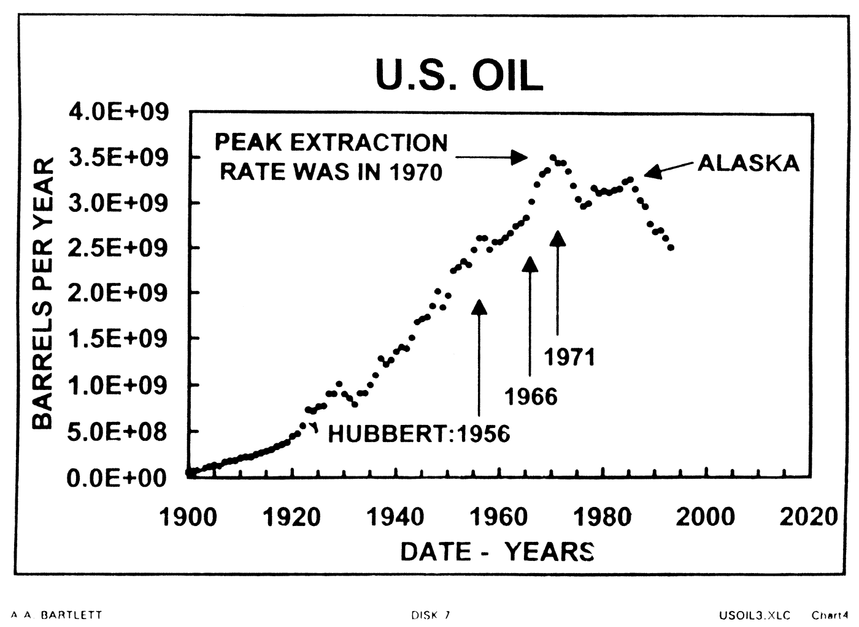

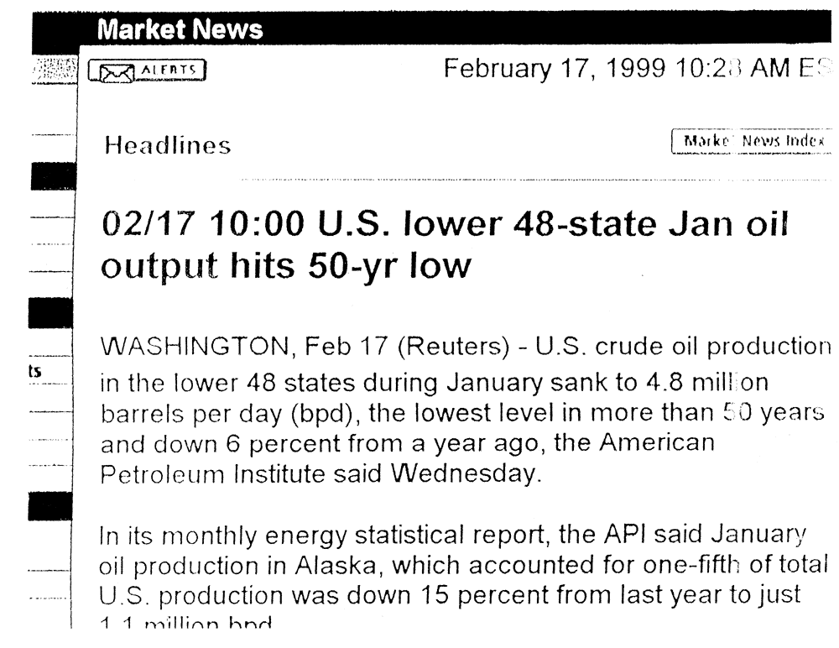

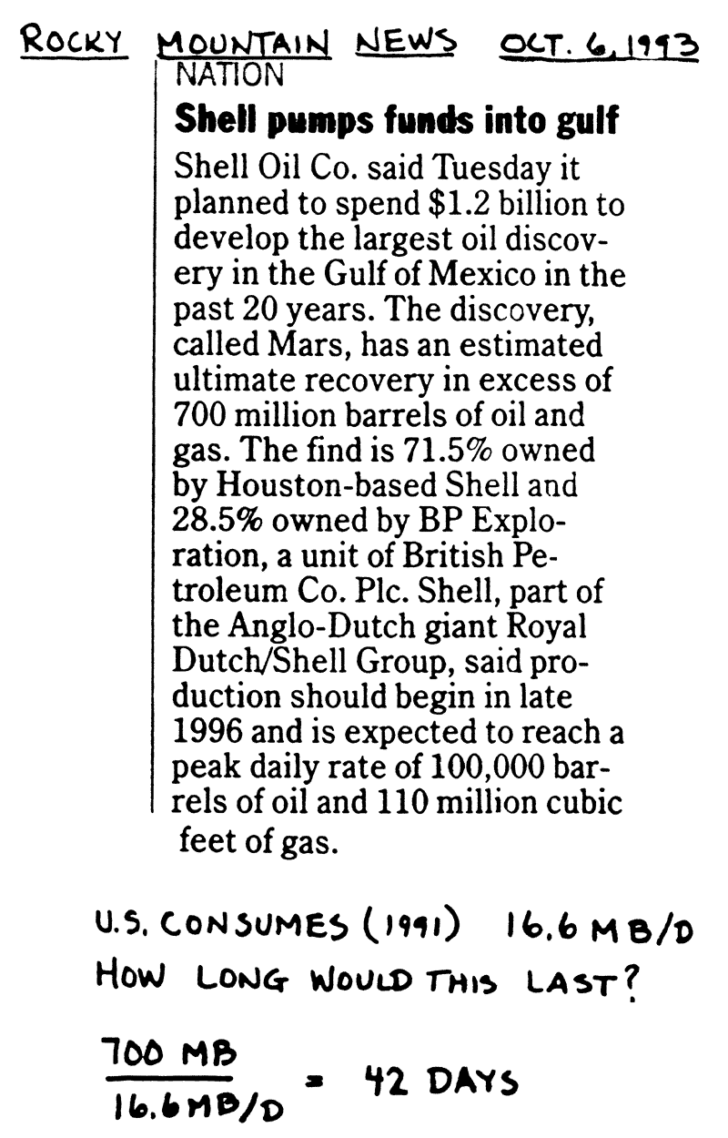


U.S. Oil Output Tumbled in First Half
As Alaska's Production Fell Nearly 8%

By Anne Reifenberg
Staff Reporter of The Wall Street Journal
U.S. crude oil output fell sharply in the first half of the year, with production from Alaska's enormous fields taking an unexpected, nearly 8% tumble, the American Petroleum Institute reported.
One consequence was another jump in the amount of imported petroleum used by Americans to 52% from 49% of total consumption.
The nation's production of oil has been tracking downward for more than a decade. But industry analysts were surprised by the rate of decline recorded in the first six months of 1996: 3.1%, more than double the 1.5% rate in the same period of 1995. And the number of oil-well confirmations, a barometer of the explorations and production sector’s health, also slipped abruptly -- by 18% -- even though crude was selling for about $2 a barrel more this spring than last.
"With prices like that, it's not as if people wouldn't have been trying to get oil out of the ground," said Ken Haley, chief economist for Chevron Corp. in San Francisco. "The question we can’t answer yet is whether this is a new trend or a quirk."
The petroleum institute, which keeps statistics for the industry, had thought the exploration-and-production boom in the Gulf of Mexico would compensate for sluggish activity in the continental U.S. "But what’s going on in the Gulf isn’t enough to completely offset the decline onshore in the lower 48," said Ed Murphy, the institute's chief economist, "and certainly not enough to make up for Alaska production falling off so very, very quickly."
Alaska's prolific North Slope fields, among the biggest in the world, were discovered nearly 30 years ago. The Slope's output peaked in 1988, at about two million barrels a day. "The only thing that companies can do in Alaska is try to slow the rate of decline," said Peter Jacquette, an energy analyst with WEFA Group in Eddystone, Pa.

World Oil Supply

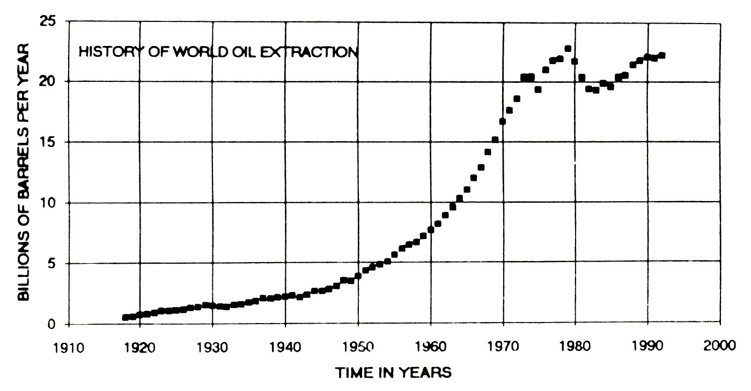

Here is an example  of the policy of  "STRENGTH THROUGH EXHAUSTION."  William Simon, Energy Advisor to U.S. President Gerald Ford:  "We should be trying to get as many holes drilled as possible to get the proven (oil) reserve."  CBS Television  August 31, 1977 | Commenting on a scientific analysis that was done by petroleum geologists,  M.A. Adelman, Emeritus Professor of Economics at M.I.T., said:  "This analysis is a piece of foolishness."  "The world will never run out of oil, not in 10,000 years."  Fortune  November 22, 1999, Pg. 194
We have non-scientists telling us  that petroleum reserves  are greater  than ever before in history,  and we have geologists  telling us that we are finding  only one new barrel of oil  for every four barrels  we pump from the ground.  WHAT'S GOING ON? | YOU CANNOT  LET OTHERS  DO YOUR  THINKING  FOR YOU!

From THE WALL STREET JOURNAL:
"Four Decades Later, Oil Field Off Canada Is Ready to Produce

Politics, Money, and Nature Put Vast Deposit on Ice;
Now, It Will Last 50 Years

'Shot in the Arm for U.S.'

… The Hibernia field, one of the largest oil discoveries in North America in decades, should deliver its first oil by year end. At least 20 more fields may follow, offering well over one billion barrels of high-quality crude and promising that a steady flow of oil will be just a quick tanker-run away from the energy-thirsty East Coast."
April 1, 1997

USE LONG DIVISION:
U.S. CONSUMPTION (1994) 18X10⁶ BARRELS/DAY
1 x 10⁹ BARRELS = 56 DAYS not "50 years"
18 x 10⁶ B/D

Dr. Julian Simon
Formerly Professor of Economics and Business Administration, University of Illinois
And in 1992, Professor of Business Administration, University of Maryland, and Adjunct Scholar of the Heritage Foundation:
Writing about oil from many sources (including biomass), Simon says,

"Clearly there is no meaningful limit to this source except the sun's energy…"
"but even if our sun were not as vast as it is, there may well be other suns elsewhere."

The Ultimate Resource
Princeton University Press, 1981, Page 49.

Coal Reserves in the United States

DATA FOR U.S. COAL  "Annual Energy Review: 1991," U.S. Department of Energy, pgs. 109, 189  Coal Demonstrated Reserve Base:  R = 4.7 x 10¹¹ tons*  *"about one-half of the demonstrated reserve base of coal in the United States is estimated to be recoverable."  R = 2.4 x 10¹¹ tons  Extraction Rates  1971 r₀ = 5.6 X 10⁸ tons/yr  1991 r₀ = 9.9 X 10⁸ tons/yr  Average Rate of Growth  2.86% per year | LIFE EXPECTANCY  OF U.S. COAL
 | Growth Rate | Recoverable | Reserve Base
 | 8% per year | 37 Years | 46 Years
 | 7 | 41 | 50
 | 6 | 45 | 56
 | 5 | 51 | 64
 | 4 | 59 | 75
 | 3 | 70 | 91
 | 2.86* | 72 | 94
 | 2 | 87 | 117
 | 1 | 121 | 174
 | 0 | 236 | 473
 | * Avg. growth rate 1971-1991
 | Data from "Annual Energy Review: 1991," U.S. Department of Energy, pgs. 109, 189
"We spent about $25 billion for imported oil last year," Beall* said, adding that any reduction in the dependence on imported oil could be greatly aided by increased use of coal.  He estimated that America's coal reserves are so huge they could last "a minimum of 300 years and probably a maximum of 1000 years."  *Director of the Energy Division of the Oak Ridge National Laboratories  Boulder Daily Camera  July 5, 1975  COMPARE THIS TO THE "LIFE EXPECTANCY OF U.S. COAL," ABOVE. | "By the lowest estimate, we have enough (coal) for 200 years, by the highest, enough for more than a thousand years."  CBS reporter Wagner  CBS Television  Special Program on Energy  August 31, 1977  HOW DOES THIS STATEMENT HOLD UP WHEN COMPARED TO THE FACTS?

NEWSWEEK MAGAZINE

In a cover story on energy (July 16, 1979) said that "at present rates of consumption" we have enough coal for "666.5 years."

DOES THAT MEAN THERE IS ENOUGH COAL FOR OVER 600 YEARS?

Don't believe any prediction
of the life expectancy of a non-renewable resource
until you have confirmed
the prediction
by repeating the calculation.

COROLLARY

The more optimistic the prediction
the greater is the probability
that it is based
on faulty arithmetic
or on no arithmetic at all.

Final Notes

